Milk Bank at Chester
NOW Food Building
University of Chester
Parkgate Road
Chester
CH1 4BJ
01244 511440
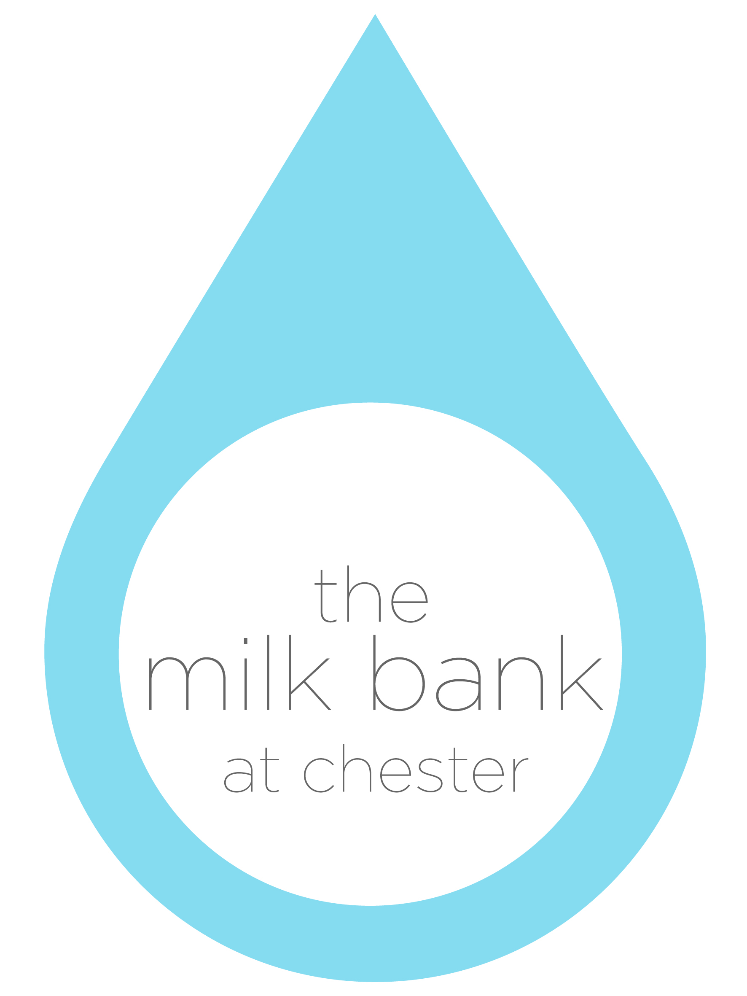

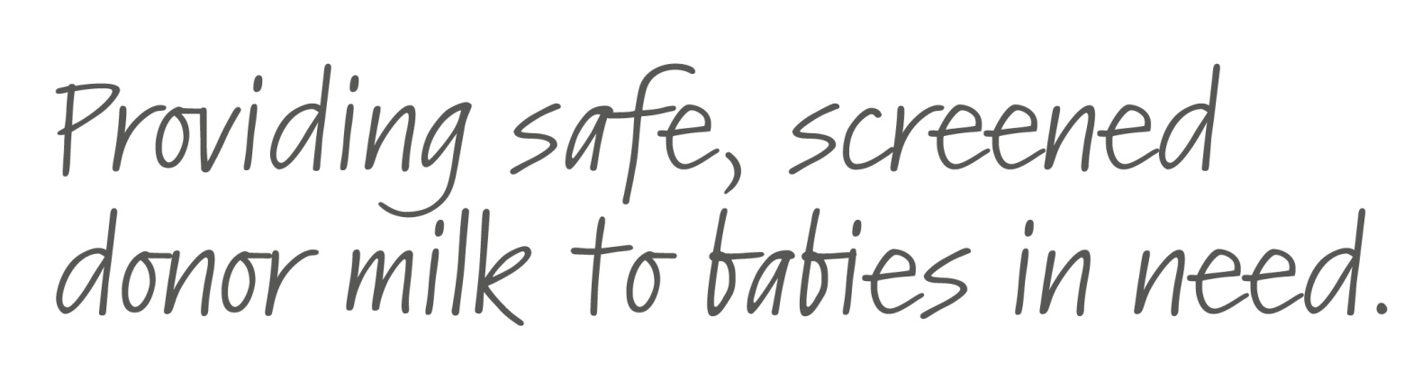

Milk Donation Guidelines
for Referring Health Professionals

The questions below are intended to help staff caring for families to discuss the possibility of donating breast milk. It is important to make the family aware that the milk bank has strict criteria for milk donation so cannot always accept milk. The questions below are basic screening questions and a more detailed screen will be undertaken by milk bank staff following a referral.
Full information about the milk bank’s donor screening and testing process can be found at www.milkbankatchester.org.uk Thank you for your support

Referring Health Professional Name & Contact Details
Donor Name, Address & Telephone Number
Comments
SCREENING QUESTIONS | Yes / No | Notes
Are you in good health?
Do you smoke or use nicotine replacement therapy including patches, chewing gum or inhalators (vaping)? |  | If yes = milk bank unable to accept milk
Do any members of your household smoke? |  | If yes = milk bank unable to accept milk
While expressing the milk, did you take any medication? |  | If potential donor has been taking certain medications including anticoagulants, painkillers other than paracetamol, antibiotics, antidepressants, blood pressure medications = milk bank unable to accept milk
Do you drink more than 1 to 2 units of alcohol, once or twice a week? |  | If yes = milk bank unable to accept milk
Was the milk expressed in the last 10 weeks? |  | If no = milk bank unable to accept milk
Was the milk frozen with 24 hours of expression? |  | If no = milk bank unable to accept milk

